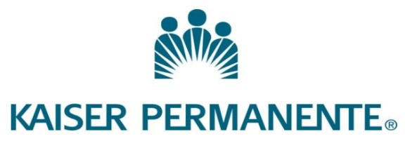
Exemplary Patient Care: How Stephaine Moreno Demonstrates Compassion, Competence and Professionalism in the Mental Health Field

To whom it may concern,
I am writing to wholeheartedly recommend Stephanie Moreno for admission to the field of therapy. As her supervisor at Kaiser Permanente Roseville, I have had the pleasure of working closely with her for the past three years and have witnessed her exceptional patient care skills firsthand.
Stephanie consistently demonstrates compassion, competence, and professionalism in the field of medical assisting. She has a natural ability to connect with patients, making them feel comfortable and easing their worries and concerns. Her empathetic nature allows her to truly understand each patient’s needs and tailor her care accordingly.
In addition to her excellent bedside manner, Stephanie possesses strong technical skills in medical assisting. She has a deep understanding of medical terminology and exhibits remarkable critical thinking and problem-solving abilities. Stephanie is proficient in administering medications and treatments and is quick to respond to emergencies.
Her attention to detail and ability to multitask ensure that every patient receives the highest level of care. Stephanie also exemplifies professionalism and a robust work ethic in her role as a medical assistant.
She consistently arrives at work on time, is well-prepared for each shift, and maintains a positive attitude, even in challenging situations. Her ability to collaborate with other healthcare professionals, including doctors, nurses, and medical staff, has earned her the respect of her peers.
In conclusion, I strongly encourage you to consider Stephanie for your counselling program. You will not be disappointed in her work or her dedication to patient care.

Sincerely,
Patty Houston
Manager, Adult and Family Medicine
Permanente Medicine
The Permanente Medical Group
North Valley Service Area
Roseville Medical Center
1600 Eureka Road
Roseville, CA 95661

